Last (family) name:

First (given) name:

Student ID:

Department of Electrical and Computer Engineering

University of Wisconsin - Madison

**ECE 270 - Electronics Circuits Lab 1**

**Exam – Fall 2021**

*Instructions:*

* Do not open the exam until you are told to do so!
* **Show all your work and give your answers with units for maximum credits.**

|  |  |  |
| --- | --- | --- |
| **Section** | **Points** | **Score** |
| 1 - Kirchoff's Law | **38** |  |
| 2 – Thevenin Equiv. | **28** |  |
| 3 - RC Circuit | **14** |  |
| 4 - OpAmp | **20** |  |
| **TOTAL** | **100** |  |

1. **Kirchoff's Law (38 points, 2 points per blank)**

Get 2 given resistors from the boxes in the parts area.

* + 1 x 100 $Ω$
  + 1 x 510 $Ω$

Reference them as R1 and R2 (with R1 < R2).

Use units for full credit on all measurements. Missing or wrong units will end up with -1 points. Use the DMM for all measurements.

For **theoretical** calculations, please use the **nominal** values.

Measure R1 and R2 with the DMM to the nearest 0.01 $Ω$.

R1 = ___98.52 $Ω$

____

R2 = ___509.23 $Ω$

___

Set the power supply to 3.8 volts.

Measure the voltage with the DMM to the nearest 0.01V.

VDC = ____3.78V____

Put resistors R1 and R2 in series. Apply the DC voltage across the 2 series resistors.

Calculate theoretically and measure the voltage across R1 and R2 to the nearest 0.01V.

VR1 = ___0.62V___ calculated. VR1 = ___0.61V___ measured.

VR2 = ___3.18V___ calculated. VR2 = ___3.16V___ measured.

Calculate theoretically and measure the current through R1 and R2 to the nearest 0.1mA. Use the 10A input jack for this measurement, setting it to 1A.

IR1 = ___0.62mA__ calculated. IR1 = ___0.62mA___ measured.

IR2 = ___0.62mA__ calculated. IR2 = ___0.61mA___ measured.

Put R1 and R2 in parallel.

Apply the DC voltage across the 2 parallel resistors.

Calculate theoretically and measure the voltage across R1 and R2 to the nearest 0.01V.

VR1 = ___3.80V___ calculated. VR1 = ___3.79V____ measured.

VR2 = ___3.80V___ calculated. VR2 = ___3.79V____ measured.

Calculate theoretically and measure the current through R1 and R2 to the nearest 0.1mA. Use the 10A input jack for this measurement, setting it to 1A.

IR1 = ___38.0mA ___ calculated. IR1 = ___38.4mA___ measured.

IR2 = ____7.5mA __ calculated. IR2 = ___7.4mA____ measured.

1. **Thevenin Equivalent (28 points)**  
     
   Step1: (12 points)  
   Find the Thevenin equivalent for the circuit in figure 1.

R1 is RLOAD

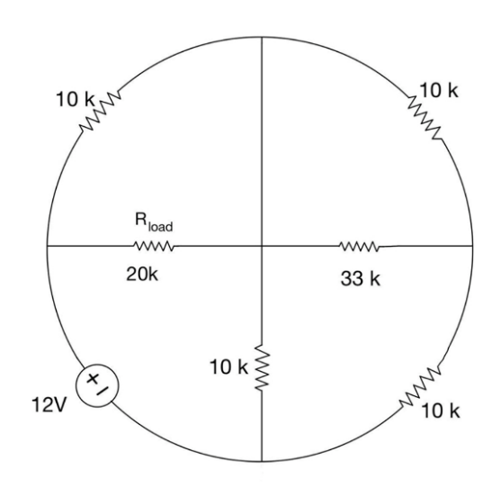

Figure 1.

**Show all your work.**

Step2: (8 points)



Draw the schematic of the Thevenin equivalent circuit of the circuit shown in Fig. 1.

Figure 2:

Step3: (8 points)

Using the Thevenin equivalent from Figure 2, build a circuit to measure the voltage across and current through the resistor $R_{Load}$. Use two resistors, if you have to, to get close for .

3) **RC Circuit (14 points)**

Design an $RC$ circuit which has a time constant of 0.1 ms, given the capacitor value 100 nF. Use 4VPP square wave voltage.

Step 1: (6 points) **Draw** the schematic for this circuit.

* What is the resistance of your resistor? __1K___
* What would be the value of your resistor if the time constant was asked to be 2ms? ___20K___

Step 2: (8 points) Build the circuit and measure the time constant using the oscilloscope. ___0.098ms____ .

**Sketch** the waveform you used to measure the time constant from the oscilloscope. Include the voltage time axes values. Mark the important time and voltage events on the sketch.

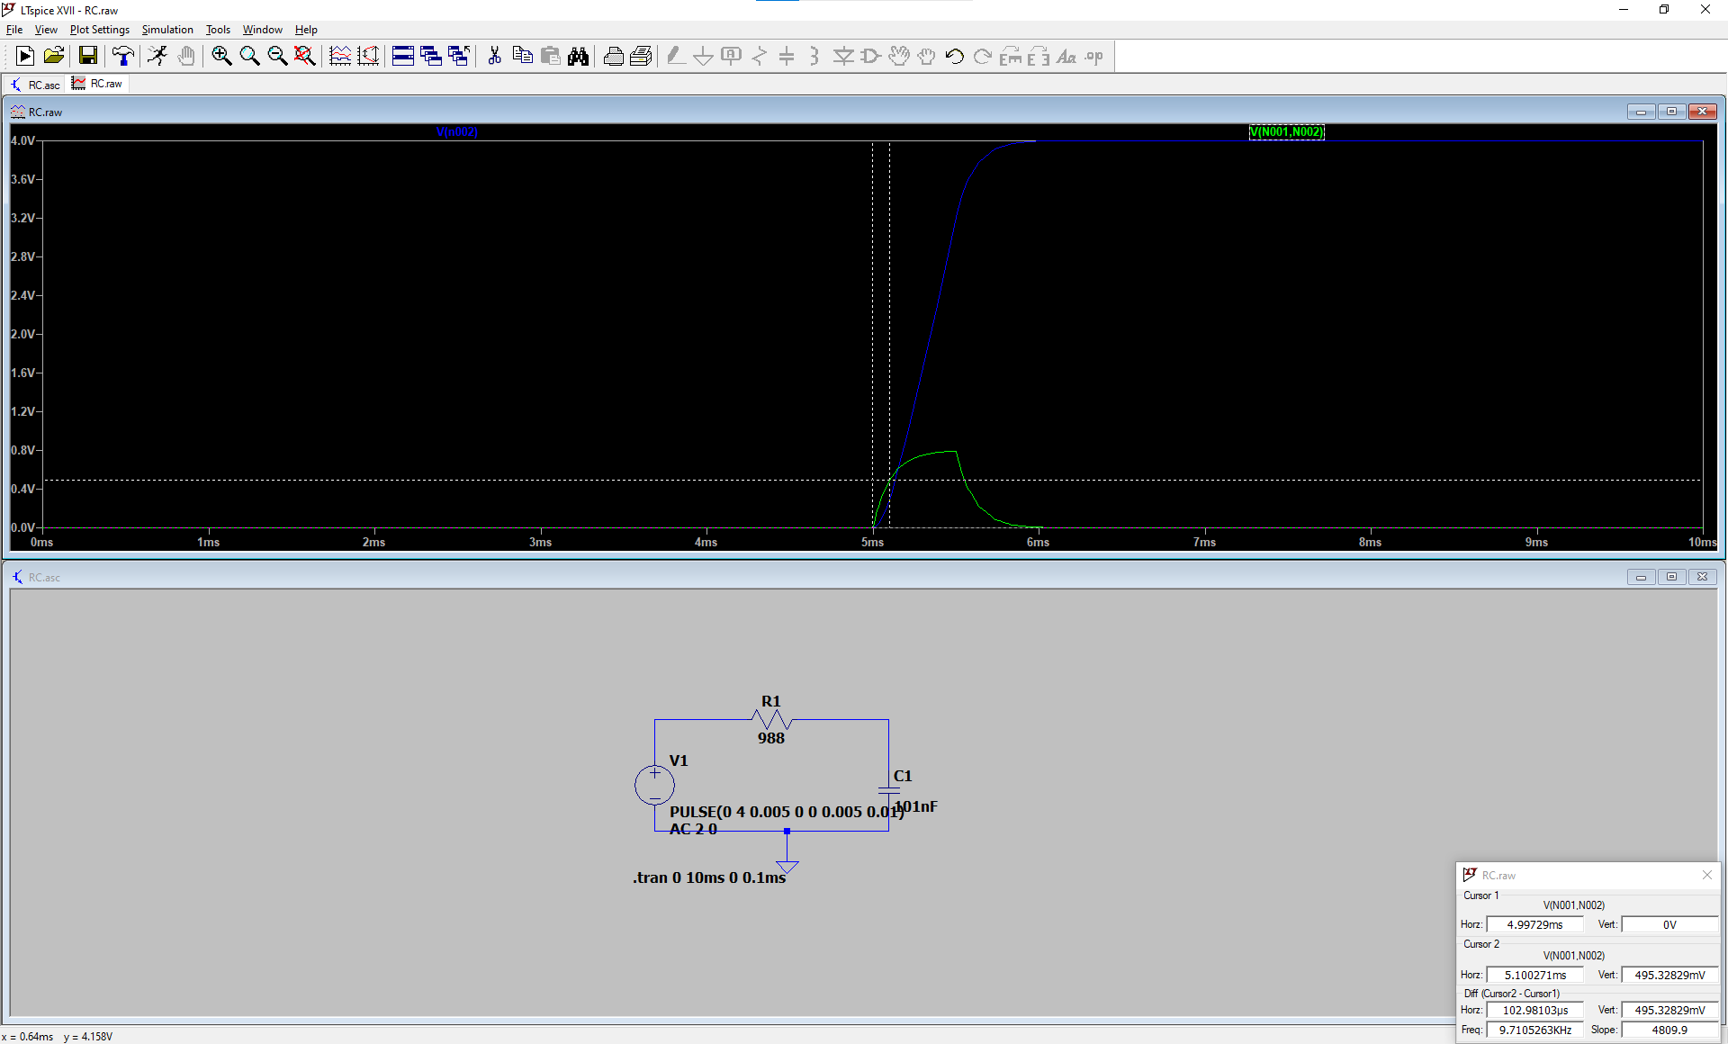

Explain how did you measure the time constant.

First, we measure the voltage across the resistor. Then calculate the value of Vfinal – Vinit. Place first cursor at the beginning of Vinit and place the second cursor at the 0.63Vfinal.

What is the frequency you used to determine the time constant? ____________

4) **OpAmp (20 points)**

The following circuit is a level detector with $V_{3}$ being a +2V to -2Vtriangular wave at frequency 100 kHz. RLOAD = 3k $Ω$. (Open loop gain of the Opamp is 1x106)

Now, answer the following questions



*Figure 3*

1. **(5 points)** What are the approximate values for maximum and minimum voltage that can be observed at the output of the OpAmp in *Figure 3*?

Vout Max = 3V

Vout Min = -3V

1. **(5 points)** If V2 = 0V, what could be the duty cycle of the voltage seen at the output?

49.6%

1. **(5 points)** If V2 = 1V, what could be the duty cycle of the voltage seen at the output?

24.2%

1. **(5 points)** What would the Duty Cycle D of the output voltage be, if V2 is between 0V and 3V? Please choose one from the following options.

* *D = 0%*
* *D = 100%*
* *0% < D < 50%*



* *50% < D < 100%*
* *None of the above*